Report: Laboratory work 4

**Tracking of a moving object which trajectory is disturbed by random acceleration**

Team #1: Viktor Liviniuk, Alina Liviniuk

In this work we develop standard Kalman filter for tracking a moving object which trajectory is disturbed by random acceleration.

Kalman filter algorithm was implemented of generated measurements of generated trajectory. The following plot shows true trajectory, generated measurements and filtered estimates of the trajectory.

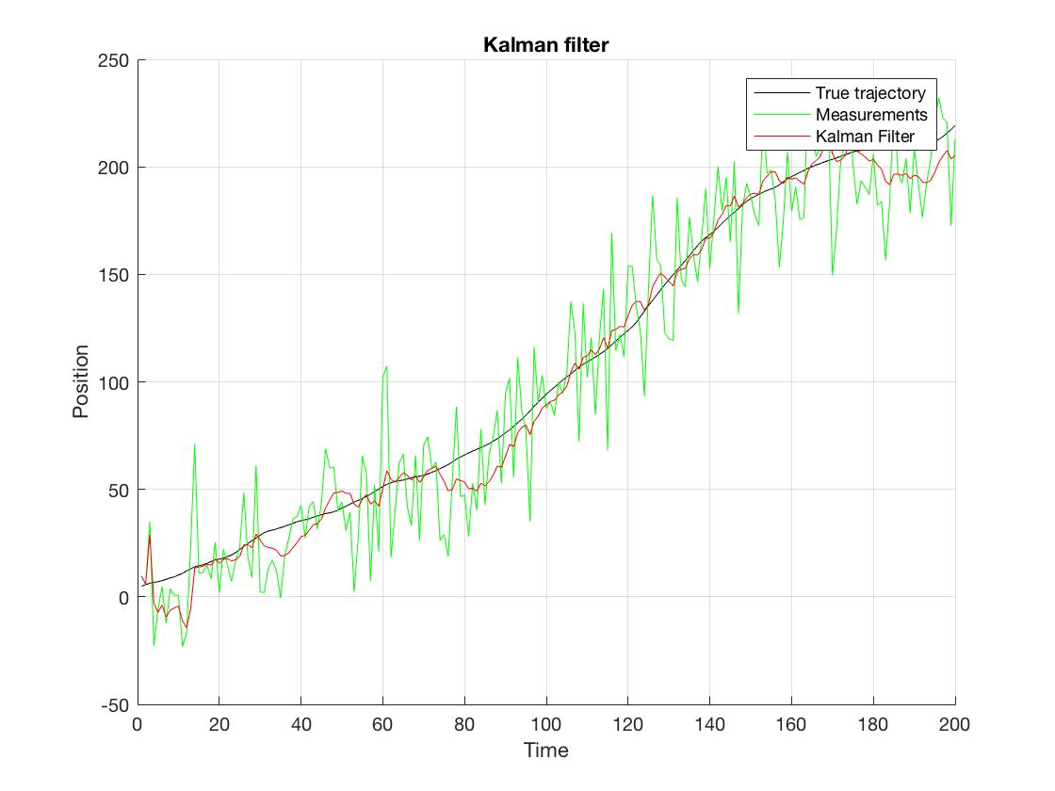

Plot of the filter gain K over the whole filtration period:

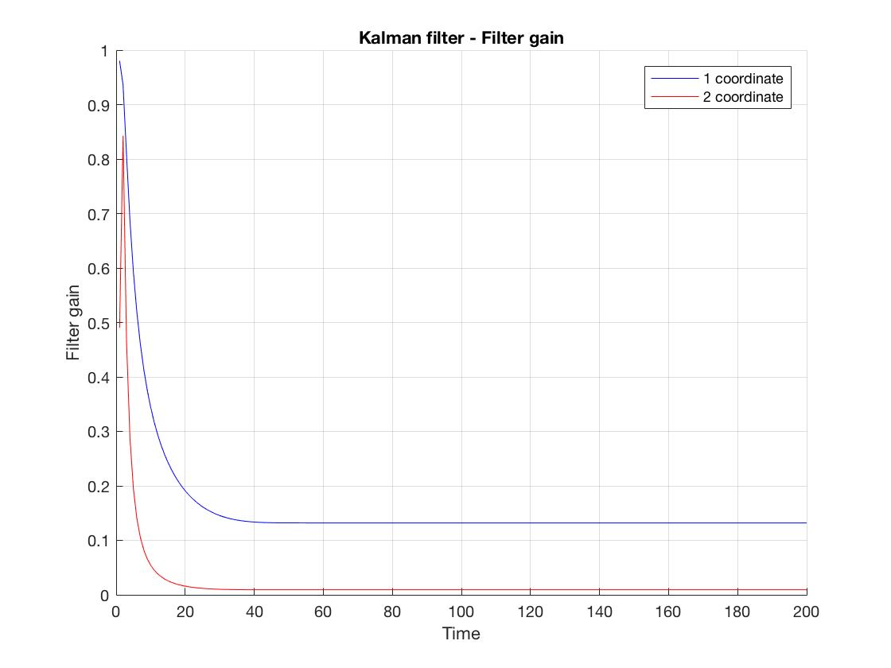

Filter gain K is great at first, but decreases to a saturated value.

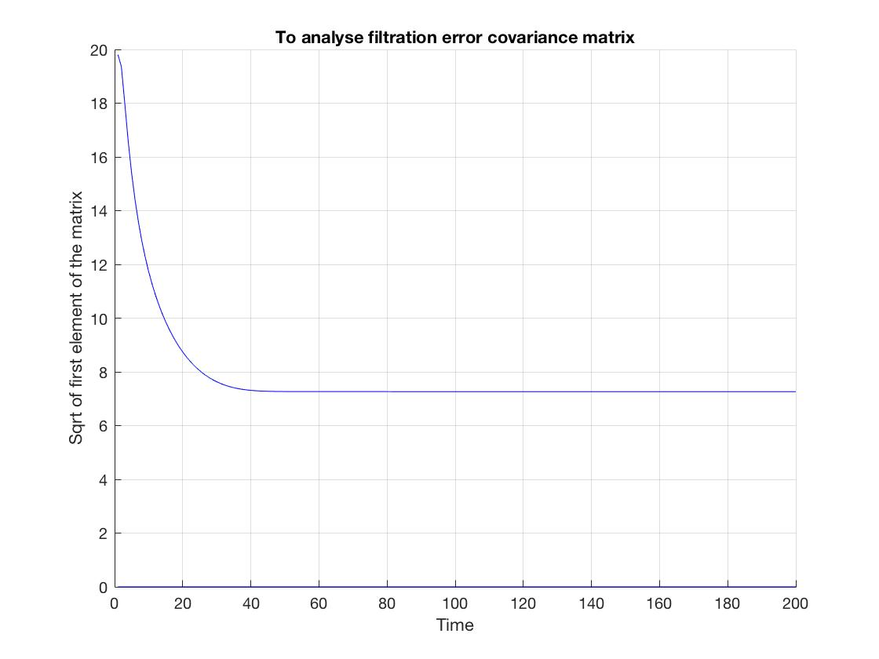

Both filter gain and filtration error covariance matrix become constant very quickly (at time around 40 seconds).

Extrapolation 7 steps ahead (using filtered data) was made. The next plot is similar to the first one, but with 7 step extrapolation displayed.

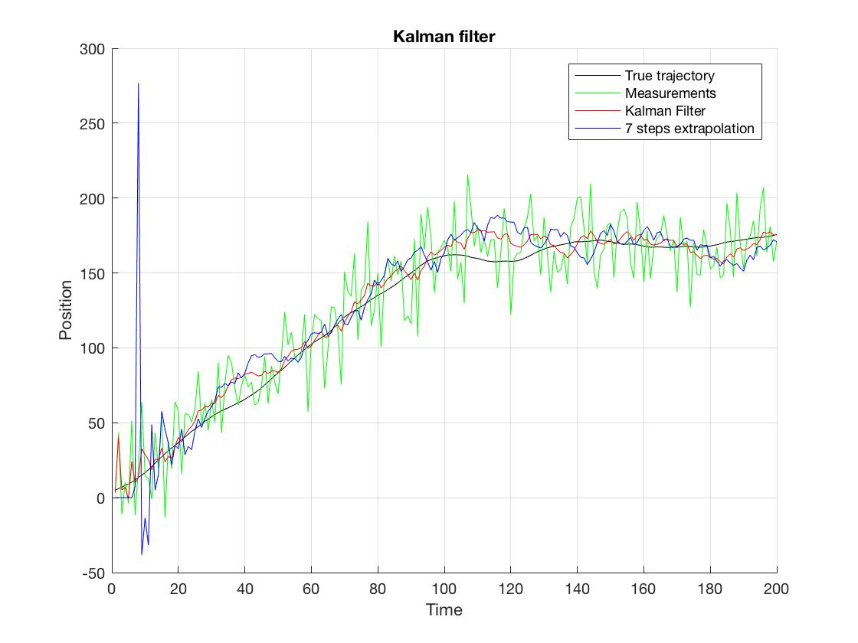

After 500 runs of filter and 7-step extrapolation, mean square error dynamics was observed. Following plot shows average values of error over 500 runs for each step.

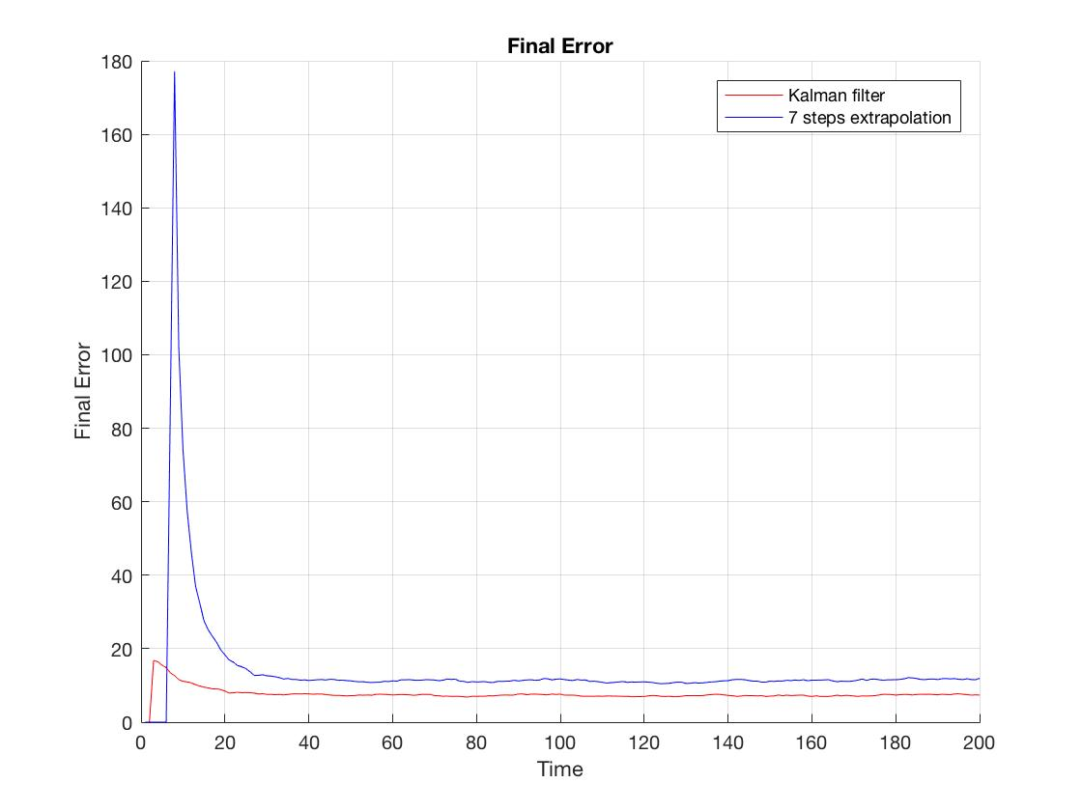

Standard deviation of measurements error was 20 and mean squared error of filtered estimates saturates on 7.2. That means the Kalman method decreases error 3-fold. 7 step prediction is not as accurate, as Kalman filtration.

With a more accurate initial filtration error covariance matrix, mean square deviation saturates on the same value, but slightly faster.

Matrixes with 10000 diagonal values were used at first, and 100 – with an index 2 (more accurate).

The comparison is shown on the next plot.

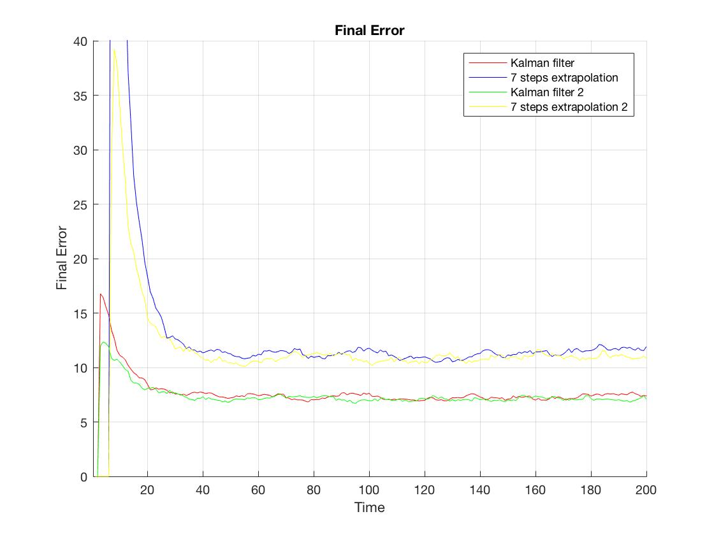

Of course, 7-step extrapolation also saturates faster.

To compare calculation errors of estimation provided Kalman filter algorithm with true estimation errors, two curves were plotted, final error obtained over 500 runs and filtration error covariance matrix (square root of the first diagonal element):

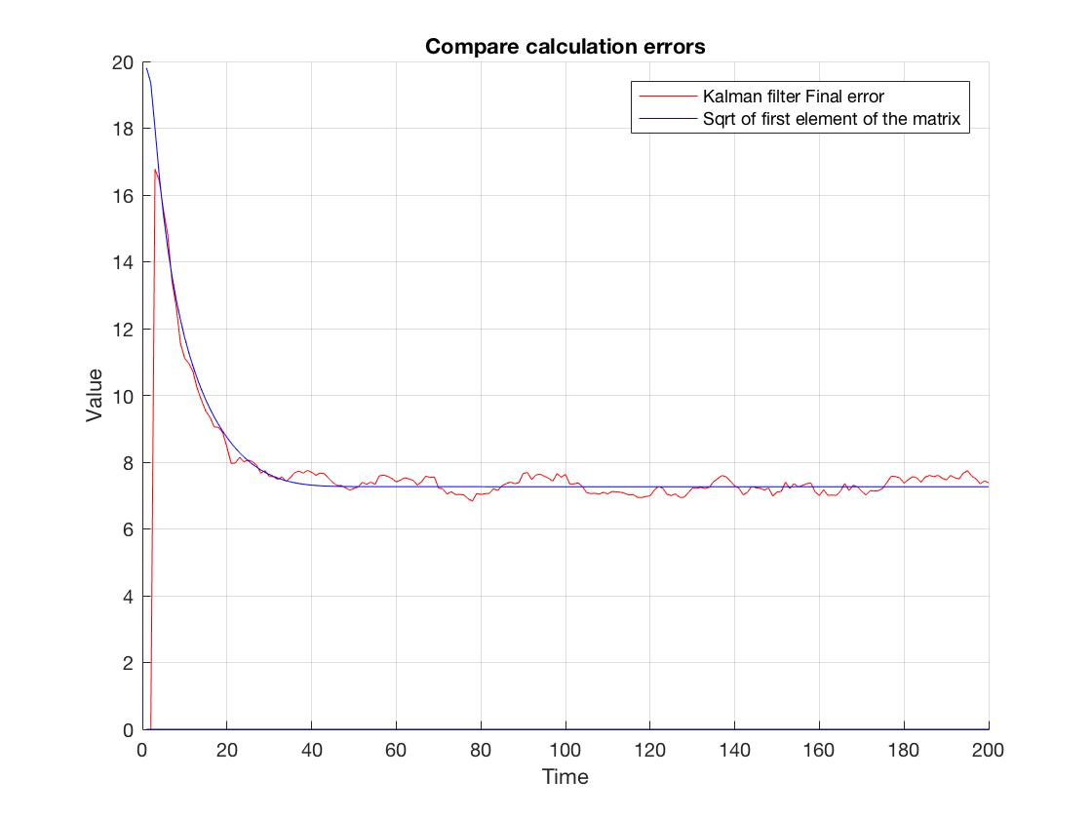

Calculation errors of estimation correspond to true estimation errors.

Filtering deterministic trajectory shows, that:

1. Filter gain approaches to zero

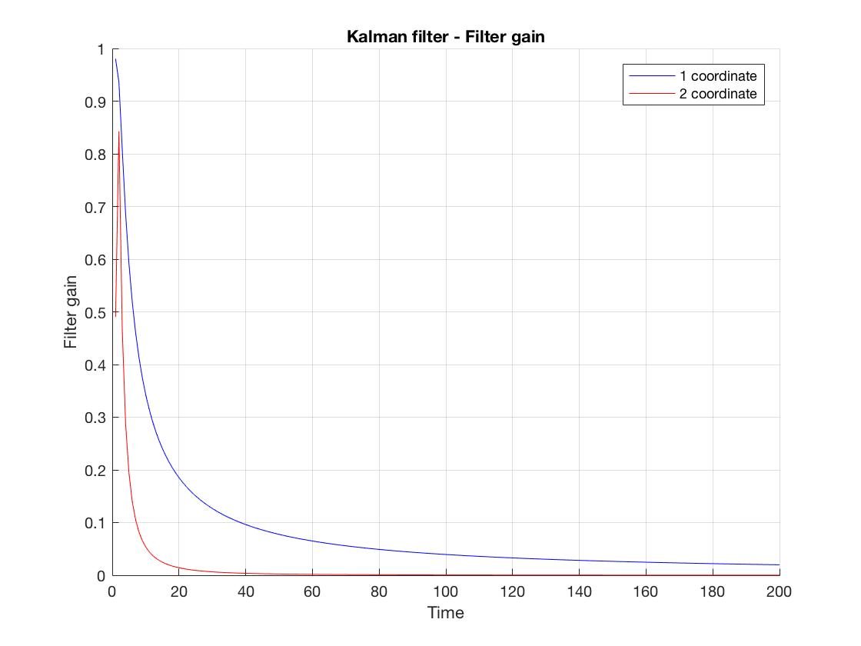

1. Both true estimation errors also approach to zero.

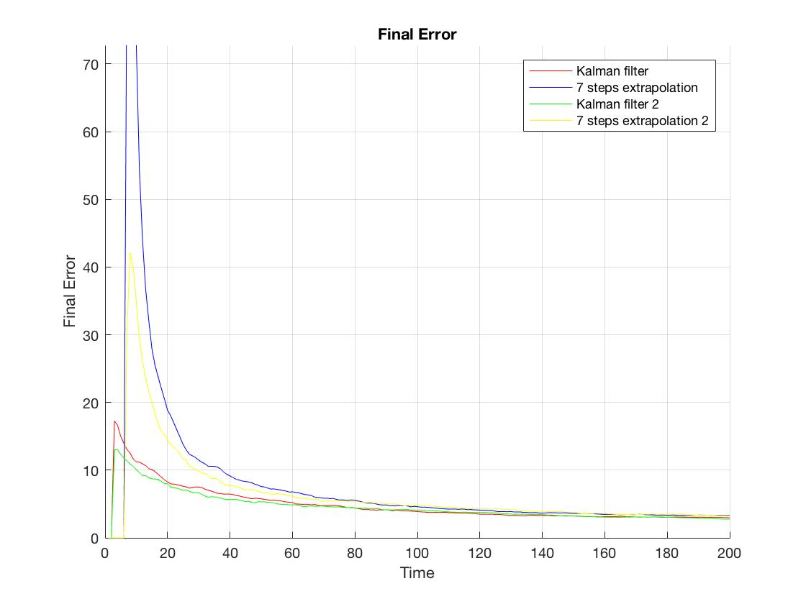

This means that in conditions of motion without any random disturbances, estimation error approaches to zero and filter switches off from measurements (new measurements almost do not adjust estimates).

If we use deterministic model of motion, but in fact motion is disturbed by random acceleration (Q = 0), we get the following results.

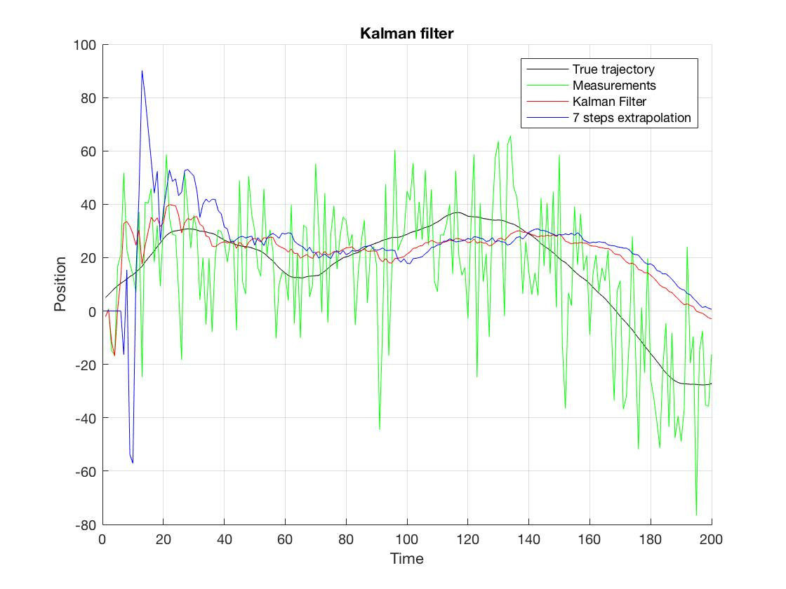  
 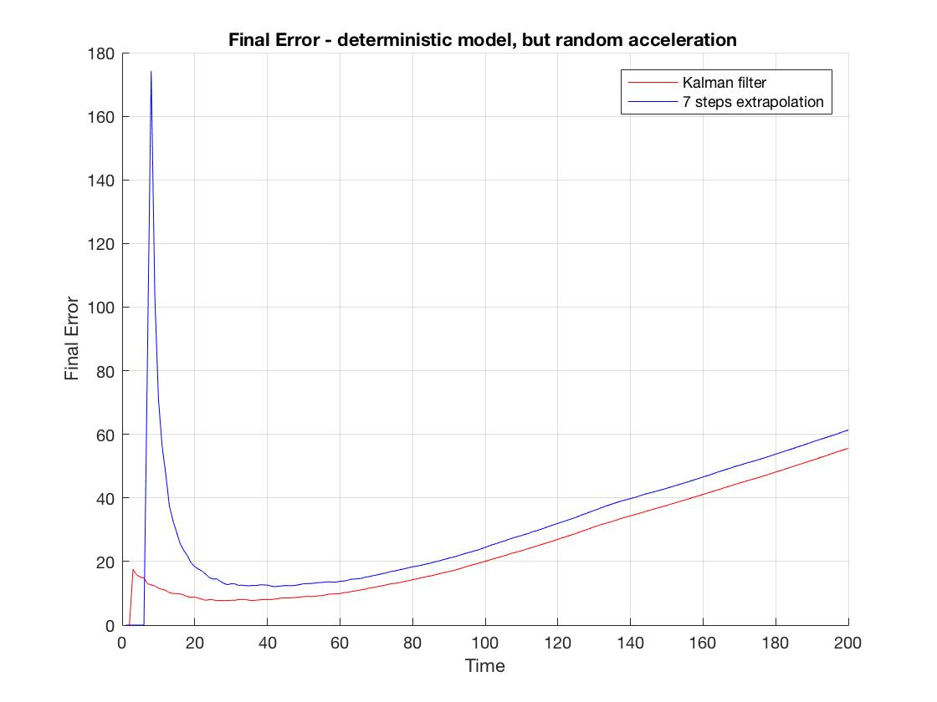

Estimation in conditions of neglecting state noise in Kalman filter algorithm is unstable (error increases), if state noise is, in fact, significant.

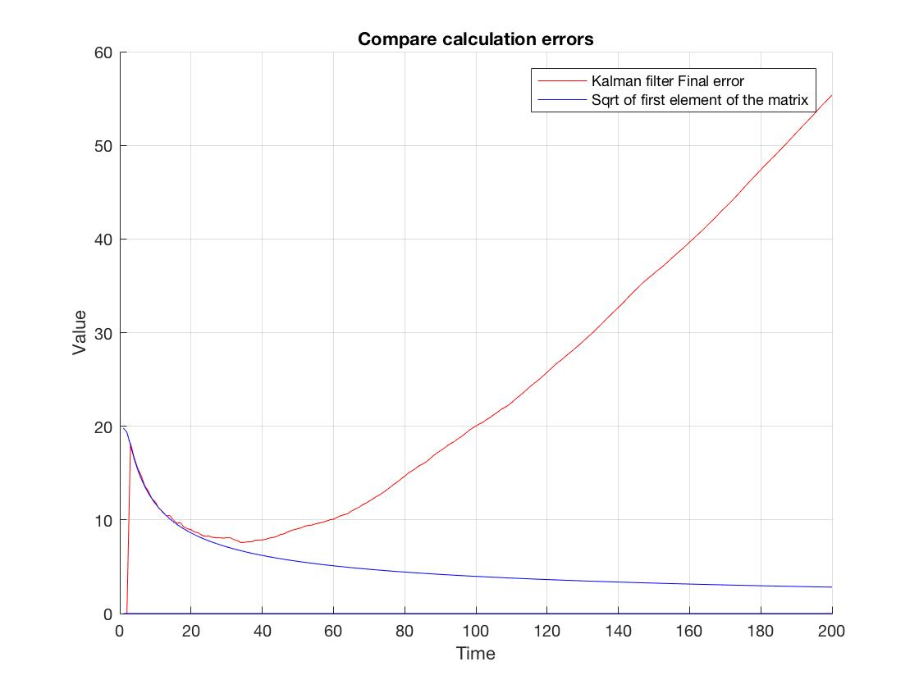

Calculation errors of estimation do not correspond to true estimation errors.

To analyze how the relationship between state and measurement noise affect time when filter gain become almost constant and estimation accuracy doesn’t increase anymore, we generate a trajectory with variance of state noise = 1 (to compare it to previous, 0.22):

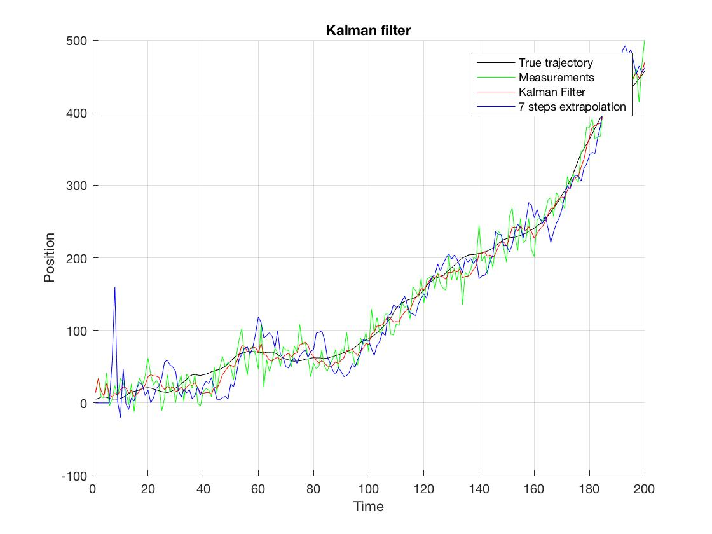

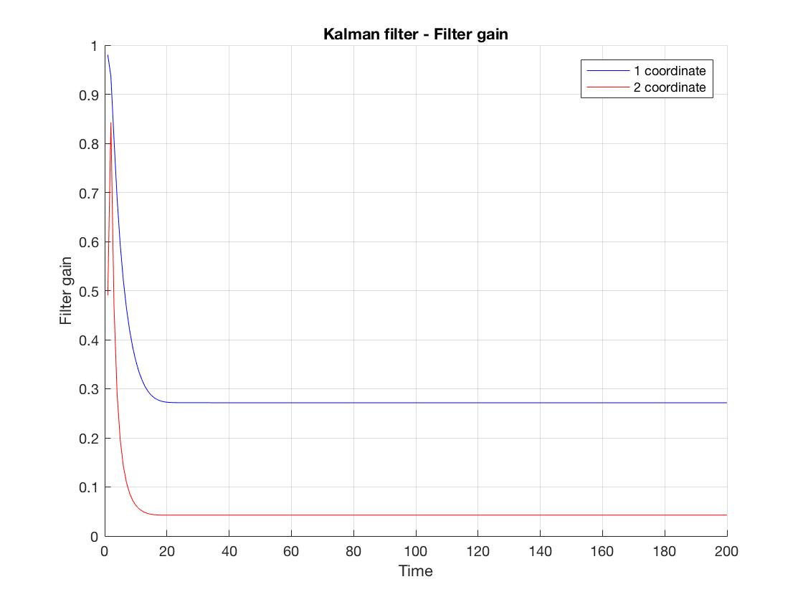

Filter gain saturated faster (around time of 15-20s) with the higher relationship between state and measurement noise.

To analyze sensitivity of filter to underestimated non-optimal filter gain 𝐾 we used initial filtered estimate 𝑋0=[100; 5] with Koptimal at first.

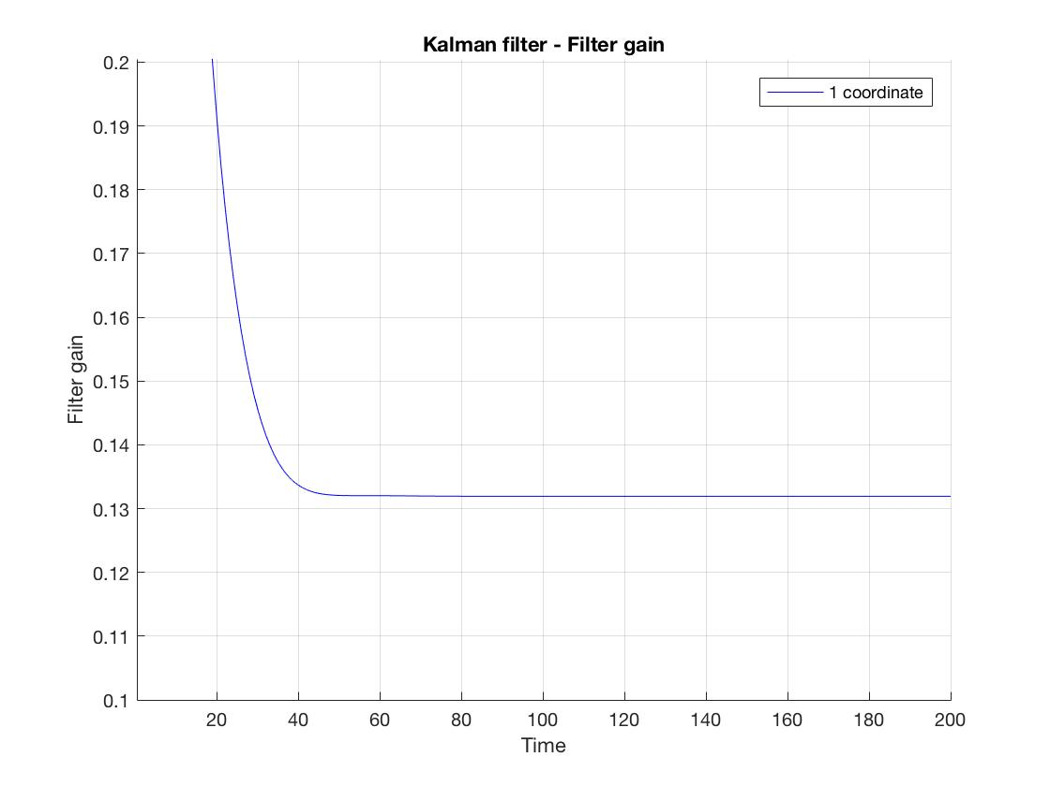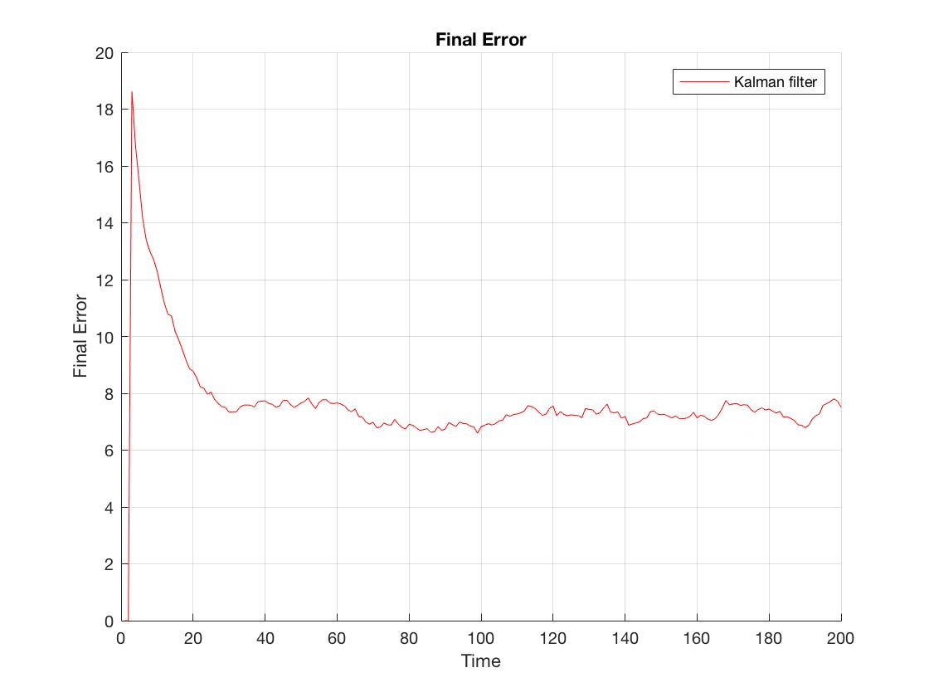

Now, the same with constant K = Ksteady-state / 5 (here Ksteady-state = [0.132; 0.009]):

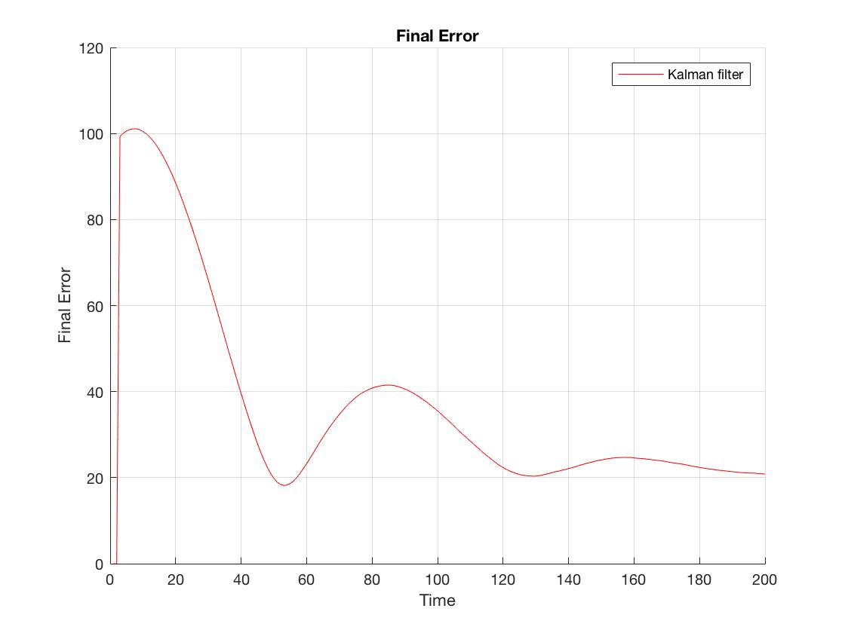

Mean squares error oscillates, with decreasing amplitude. Kalman filter is sensitive to estimation of optimal K.

The filtration looks like this:

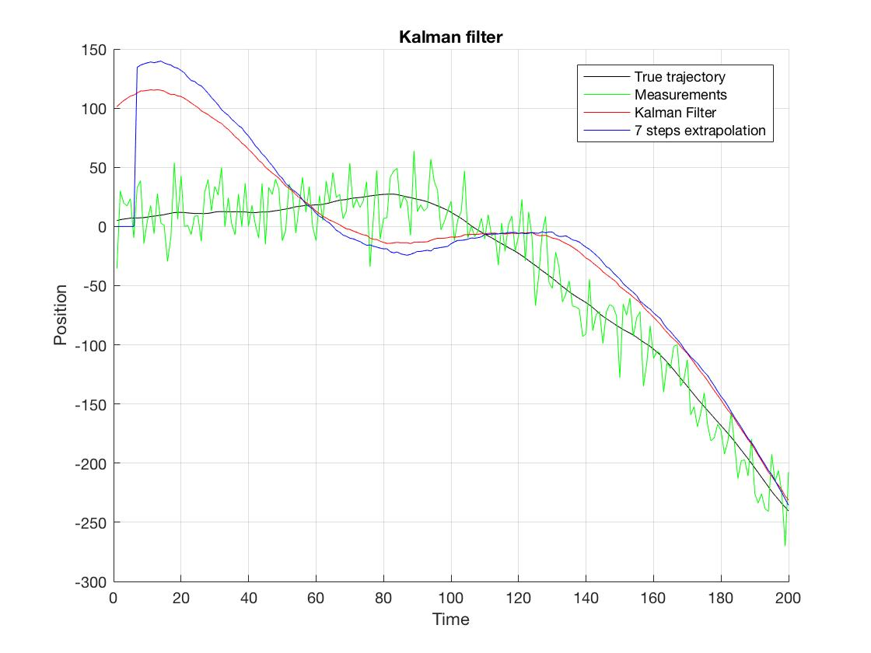

**Conclusion**

Kalman filter provides estimates of variable parameters (x, V), when LSM – of constant variables. It is sensitive to estimation of optimal filter gain.

Files with matlab code are attached.